

**BeautéPanda: Android Application for Beauty Enthusiasts**

**BIT304 FINAL YEAR PROJECT I**

**PROJECT MANAGEMENT PLAN**

(E1500352) Ayu Chrisniyanti

(E1500367) Lovely

Submitted to the

FACULTY OF COMPUTING AND DIGITAL TECHNOLOGY

(SCHOOL OF INFORMATION AND COMMUNICATION TECHNOLOGY)

In partial fulfilment of the requirements

for the degree of

Bachelor of Information Technology (HONS)

HELP UNIVERSITY

SEPTEMBER - DECEMBER 2018

# CHAPTER 2: PROJECT MANAGEMENT PLAN

## 2.1 Introduction

Project management plan is an important aspect in any type of project. The purpose of this plan is to help project team members have a clear understanding on what tasks should be carried out to achieve the project end goals, who should do it and when it should be done. Tasks and milestones are set in the beginning so that project members will know what is expected to finish the project.

Our project management plan starts from September until December 2018, which has been determined by the university. We have around 14 weeks to finish this BIT304 Final Project 1. Having project management plan will assist us in finishing the documents and codes for our applications within the time given, and to avoid the project not finish on the ending due date.

**2.2 Work Item List**

**Table 2.1: Work Item List**

|  |  |  |  |
| --- | --- | --- | --- |
| **Name / Description** | **Priority** | **Assigned To** | **Effort estimated (days)** |
| **Initiating** |  |  |  |
| Initial Meeting with Supervisor | High | Niya and Lovely | 1 |
| Project Theme Identification | High | Niya and Lovely | 1 |
| Supervisor Consultation | High | Niya and Lovely | 1 |
| Project Theme Decision | High |  | 0 |
| **Planning** |  |  |  |
| Develop Project Background | High | Niya | 2 |
| Develop Project Aims and Objectives | High | Lovely | 2 |
| Develop Work Item List | Medium | Lovely | 1 |
| Develop Project Schedule | Medium | Niya | 1 |
| Select Software Methodology | Medium | Niya and Lovely | 1 |
| Develop Resource Plan | Medium | Lovely | 1 |
| Develop Risk Management Plan | High | Lovely | 1 |
| Submission of Project Plan | High |  | 0 |
| Submission of Project Management Plan | High |  | 0 |
| **Executing** |  |  |  |
| Gathering Requirements | High | Niya and Lovely | 4 |
| Develop Literature Review | High | Niya and Lovely | 5 |
| Literature Review Submission | High |  | 0 |
| Prepare for Interim Presentation | Medium | Niya and Lovely | 9 |
| Interim Presentation | High |  | 0 |
| Develop Requirement Analysis | High | Niya | 3 |
| Develop Functional & Non-Functional Requirement | High | Lovely | 4 |
| Develop Use Case Diagram | Medium | Niya and Lovely | 2 |
| Chapter 3 Submission | High |  | 0 |
| Develop Analysis Class Diagram | High | Niya and Lovely | 1 |
| Develop Sequence Diagram | High | Niya and Lovely | 1 |
| Database Design | Medium | Niya | 1 |
| Structural Design | Medium | Lovely | 1 |
| User Interface Design | High | Niya | 4 |
| **Construction** |  |  |  |
| Coding for Prototype | High | Niya and Lovely | 3 |
| Testing | High | Niya and Lovely | 1 |
| Chapter 4 Submission | High |  | 0 |
| **Closing** |  |  |  |
| Develop Progress Report | High | Niya and Lovely | 6 |
| Prepare Final Documentation | High | Niya and Lovely | 3 |
| Final Report Submission | High |  | 0 |
| Final Presentation Preparation | High | Niya and Lovely | 4 |
| Final Presentation | High |  | 0 |

**2.3 Work Breakdown Structure**

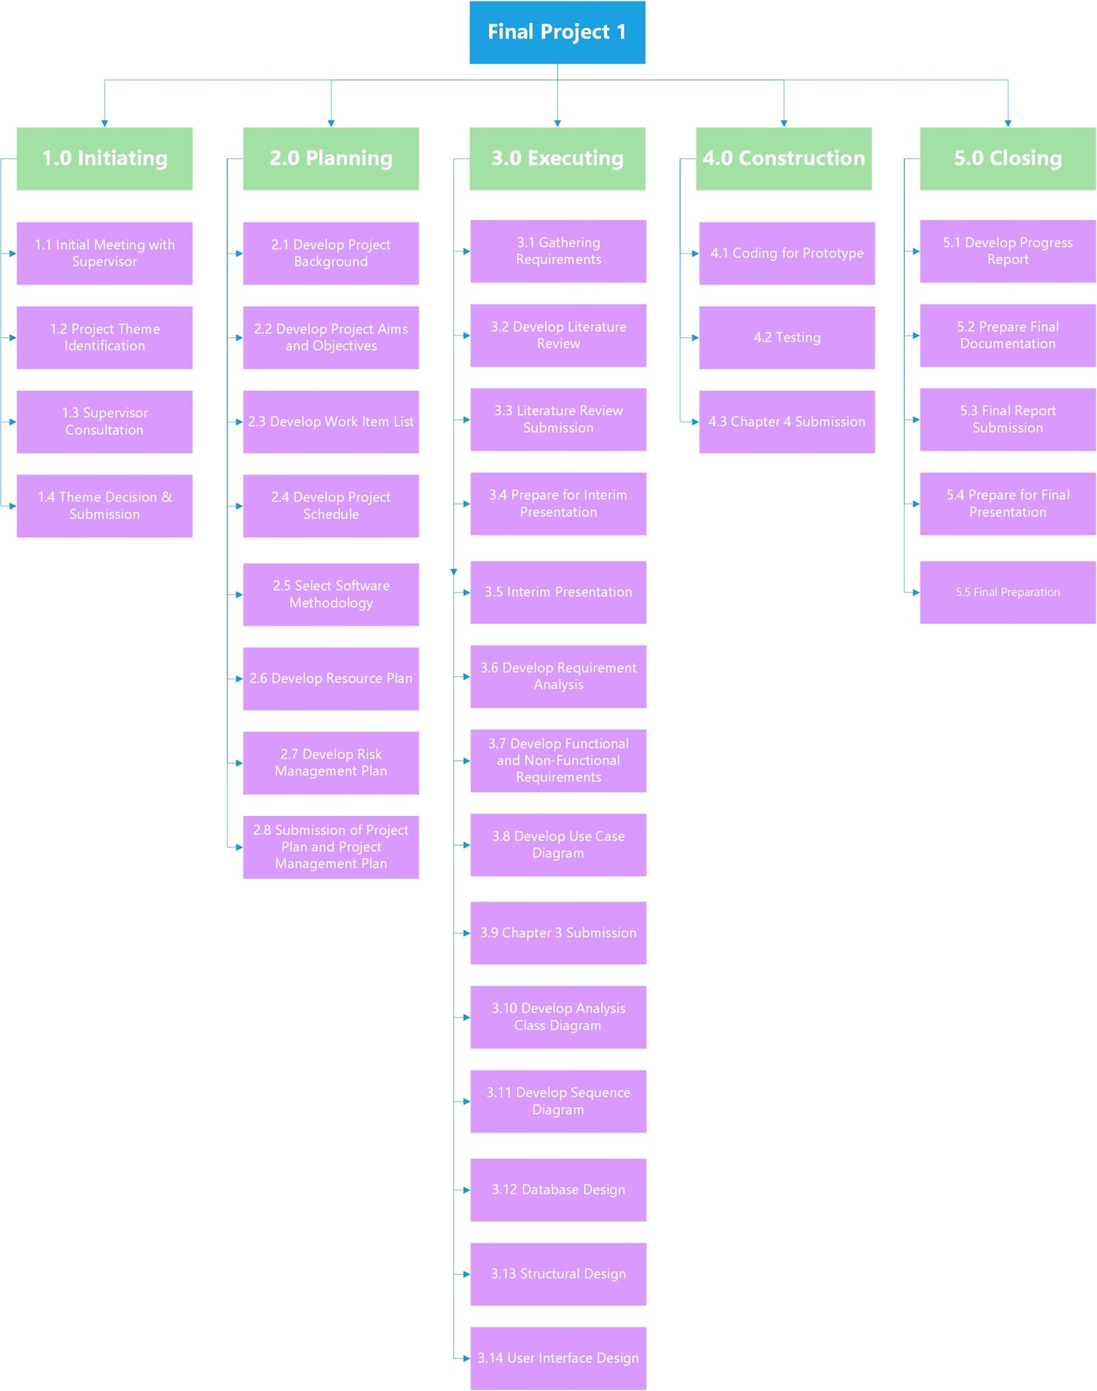

*Figure 2.1 Work Breakdown Structure (WBS)*

**Table 2.2: Work Breakdown Structure**

|  |  |  |  |  |
| --- | --- | --- | --- | --- |
| Phases and Activities | Start Date | End Date | Duration in Days | Number of Resources (hours) |
| 1. **Initiating**    1. Initial Meeting with Supervisor    2. Project Theme Identification    3. Supervisor Consultation    4. Theme Decision & Submission | 9/28/2018  10/1/2018  10/2/2018  10/3/2018 | 9/28/2018  10/1/2018  10/2/2018  10/3/2018 | 1  1  1  0 | 3  9  2  5 |
| 1. **Planning**    1. Develop Project Background    2. Develop Project Aims and Objectives    3. Develop Work Item List    4. Develop Project Schedule    5. Select Software Methodology    6. Develop Resource Plan    7. Develop Risk Management Plan    8. Submission of Project Plan    9. Submission of Project Management Plan | 10/3/2018  10/5/2018  10/9/2018  10/10/2018  10/11/2018  10/11/2018  10/11/2018  10/12/2018  10/26/2018 | 10/4/2018  10/8/2018  10/9/2018  10/10/2018  10/11/2018  10/11/2018  10/11/2018  10/12/2018  10/26/2018 | 2  2  1  1  1  1  1  0  0 | 9  5  10  4  6  5  5  0  0 |
| 1. **Executing**    1. Gathering Requirements    2. Develop Literature Review    3. Literature Review Submission    4. Prepare for Interim Presentation    5. Interim Presentation    6. Develop Requirement Analysis    7. Develop Functional & Non-Functional Requirement    8. Develop Use Case Diagram    9. Chapter 3 Submission    10. Develop Analysis   Class Diagram   * 1. Develop Sequence   Diagram   * 1. Database Design   2. Structural Design   3. User Interface   Design | 10/15/2018  10/19/2018  10/26/2018  10/29/2018  11/9/2018  11/12/2018  11/15/2018  11/21/2018  11/23/2018  11/26/2018  11/26/2018  11/27/2018  11/27/2018  11/28/2018 | 10/18/2018  10/25/2018  10/26/2018  10/8/2018  11/9/2018  11/14/2018  11/20/2018  11/22/2018  11/23/2018  11/26/2018  11/26/2018  11/27/2018  11/27/2018  11/28/2018 | 4  5  0  9  0  3  4  2  0  1  1  1  1  4 | 9  12  0  6  0  8  7  8  0  6  6  6  6  12 |
| 1. **Construction**    1. Coding for Prototype    2. Testing    3. Chapter 4 Submission | 12/4/2018  12/4/2018  12/7/2018 | 12/6/2018  12/4/2018  12/7/2018 | 3  1  0 | 12  12  0 |
| 1. **Closing**    1. Develop Progress Report    2. Prepare Final Documentation    3. Final Report Submission    4. Prepare for Final Presentation    5. Final Presentation | 12/10/2018  12/18/2018  12/21/2018  12/24/2018  12/28/2018 | 12/17/2018  12/20/2018  12/21/2018  12/24/2018  12/28/2018 | 6  3  0  4  0 | 5  8  0  8  0 |

## 2.4 Risks Management

Every activity that is related to business will have some risks to certain extent. These risks must be analyzed and mitigation plan should be provided to overcome the risks. To deal with the risks that might occur in our project, we have identified potential risks, assessed and analyzed them, and we will be monitoring them until the project is done.

**Table 2.3: Risks Management**

|  |  |  |  |
| --- | --- | --- | --- |
| **Risk** | **Potential Impact on Project Success**  **L/M/H** | **Likelihood of Occurrence**  **L/M/H** | **Mitigation Plan** |
| Lacking the skills and knowledge to develop a wholesome android application | H | H | Find online sources to learn how to properly develop android application and find an expert to consult or to give guidance |
| The application produced will have many bugs | H | M | Run unit and integration testing to the codes to find bugs, and run system testing when the application prototype has been created |
| Project is not finished within project period | H | M | Regularly hold meetings between project members so that the project is not neglected |
| Not being able to produce proper UML diagram to show the workflow of the application | M | M | Revise previous lecture notes for creating UML diagram and consult with the project supervisor to give corrections to the diagram |
| Loss of data due to virus infection | H | L | Regularly make a backup for all the files related to the project |

## 2.5 Gantt Chart

This is our Gantt chart for this project. It starts on 28th September 2018 which is the first meeting with the supervisor where we propose our idea for this project. The project duration will be around 14 weeks, which will end on 28th December 2018 with final presentation for this BIT304 course. We use GanttProject to create the chart because it has great features and it is open source.

By creating a Gantt chart for this project, we can assign which member is responsible for a task and the duration for that task. We can also compare the project schedule with the actual duration taken to finish a task, and identify the critical path of the project where slacking cannot happen. This will help us to identify which tasks should be prioritized. In our Gantt chart, we have several milestones which are: deciding project theme, submitting project plan, submitting project management plan, submitting literature review, interim presentation, submitting chapter 3 and 4, submitting final report and do the final presentation.

**Table 2.4: Milestones**

|  |  |  |
| --- | --- | --- |
| Milestones | Tasks | Estimation Completion Date |
| Project Theme Decision | Initiating | 3rd October 2018 |
| Submission of Project Plan | Planning | 12th October 2018 |
| Project Management Plan | Planning | 26th October 2018 |
| Literature Review Submission | Executing | 26th October 2018 |
| Interim Presentation | Executing | 9th November 2018 |
| Chapter 3 Submission | Executing | 23rd November 2018 |
| Chapter 4 Submission | Construction | 7th December 2018 |
| Final Report Submission | Closing | 21st December 2018 |
| Final Presentation | Closing | 28th December 2018 |

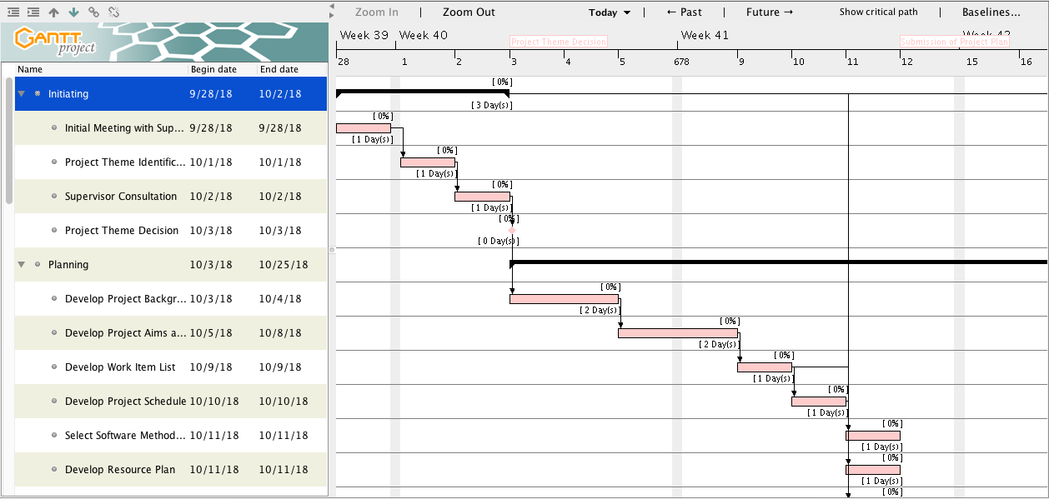

*Figure 2.2 Gantt Chart*

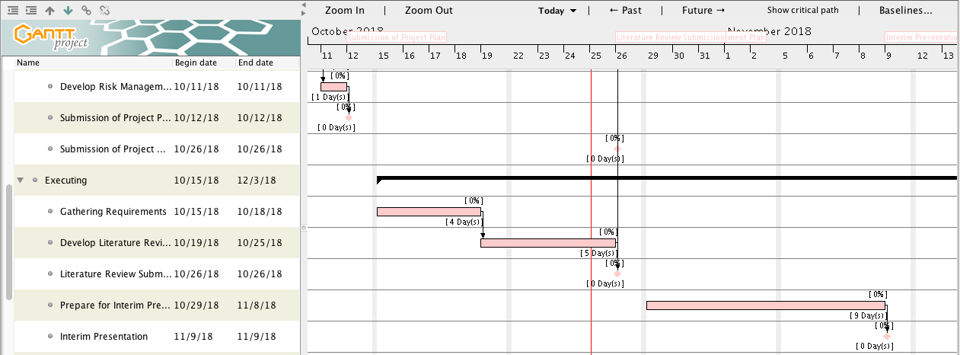

*Figure 2.3 Gantt Chart*

# 

*Figure 2.4 Gantt Chart*

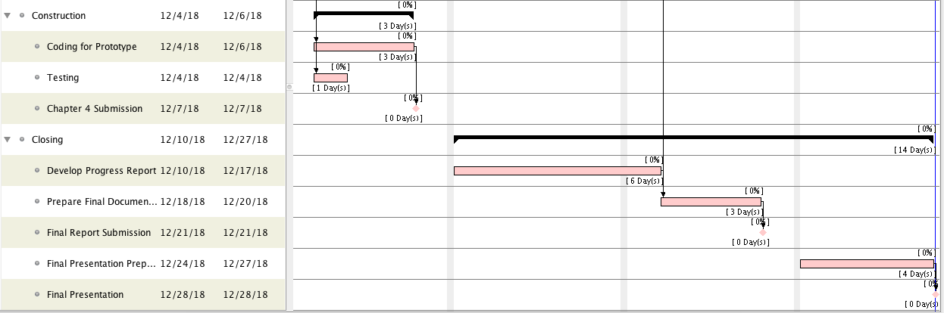

*Figure 2.5 Gantt Chart*